My website will be based on the game Genshin Impact.

Genshin Impact is an open-world action RPG (role-playing game) that takes place in the [fantasy world](https://en.wikipedia.org/wiki/Fantasy_world) of Teyvat, home to seven nations, each of which is tied to a different element and ruled by a different god.

The game has over 80 characters, each with their own region, elements, personality… ect. In order to upgrade each character’s talent/skill, there are specific sets of materials needed to collect some of which are only available on specific days of the week.

The entity of my website will be based on the characters and the materials needed to collect for the upgrade of each character. Example:

Character: Neuvillette

Element: hydro

Region: fontaine

Talent upgrade material: Equity x114

* Domain (where to get it): Pale Forgotten Glory
* Available on: monday, thursday, sunday

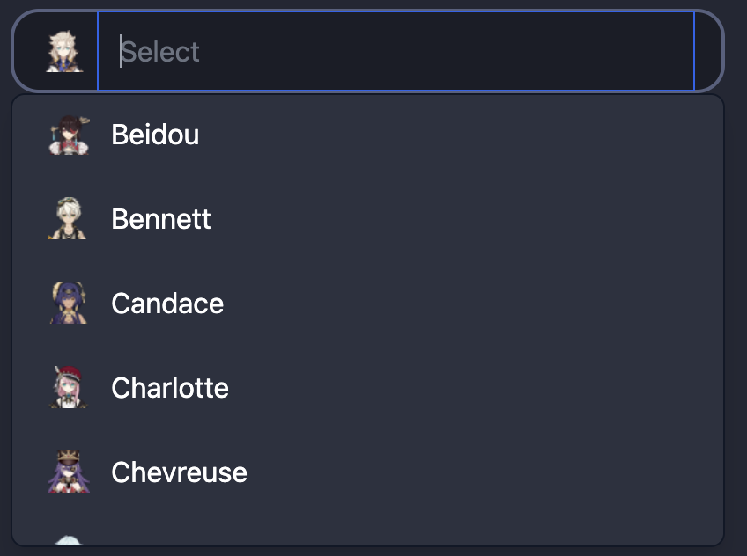

Users will be able to search for a specific character via a search bar then click on a character profile.

Where they would be shown basic character information, and choose whether or not to add the characters talent upgrade material to a to-do list/check list, which would also add the corresponding domain to a timetable-like thing.

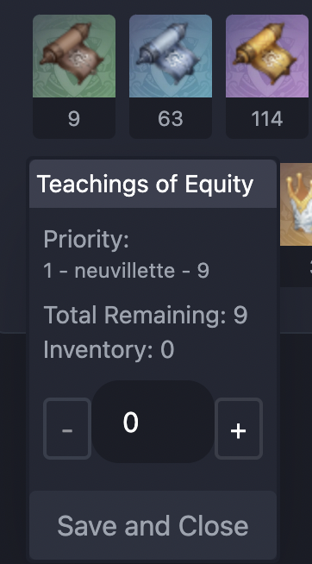

User will also be able to increase/decrease the quantity of materials left to collect